Segmentation – team preparation template

Team Meeting Preparation Sheet for Segmentation Attractiveness Index and Target Setting
Date: [Insert Date]
Version: 1.0
Icon: 🎯 A bullseye symbolizing focus and precision.

Inspirational Quotes
Start Quote:
"Knowing your market is knowing your battlefield. The more you know, the fewer the surprises."
End Quote:
"Success is not just about finding opportunities; it's about preparing to seize them."
Icons: 💡 A light bulb for inspiration and 🔎 a magnifying glass for strategic focus.

Purpose of the Meeting
Connection to Sprint Goals:
This meeting ensures the team collectively identifies high-value market segments, evaluates their attractiveness, and aligns on measurable market share targets. It builds on individual preparation, bringing together diverse insights to refine strategic decisions.
Importance of Tailored Participation:
Each team member’s preparation and unique perspective are critical for a comprehensive analysis. Active engagement will sharpen focus, prioritize opportunities, and create a clear action plan.
Icon: 📍 A roadmap symbolizing direction and purpose.

Pre-Mortem Instructions
Potential Issues:
- Unclear Criteria for Segment Ranking:
  - Risk: Misalignment on how to prioritize size, profitability, trend, and fit.
- Overanalysis Paralysis:
  - Risk: Getting bogged down in data precision, delaying decision-making.
- Derailing Discussions:
  - Risk: Team debates straying from the agenda, reducing focus.
Preventive Strategies:
- Alignment Workshop:
  - Strategy: Agree on weighted criteria for the attractiveness index before ranking.
- 70% Rule:
  - Strategy: Emphasize actionable insights over perfect data.
- Facilitator Intervention:
  - Strategy: Use time checks and redirect questions to maintain focus.
Icon: 🛡️ A shield symbolizing safeguarding against challenges.

What to Prepare
Detailed Review Instructions:
- Revisit the Brain Juice document:
  - Behavioral segmentation methodology.
  - Steps to build and weight the attractiveness index.
  - Setting and aligning market share targets.
Completion of Assigned Tools:
- Ensure the following are ready:
  - Initial behavioral segment analysis.
  - Draft attractiveness index rankings.
  - Preliminary market share targets.
Specific Discussion Points:
- Present the most compelling insights from your behavioral analysis.
- Suggest weightings for the attractiveness index criteria.
- Propose realistic market share targets for high-value segments.
Icons: 📘 A book for review, ✅ a checklist for completion, 💬 speech bubbles for discussion.

Proposed Meeting Agenda
- Opening Remarks (5 minutes)
  - Overview of sprint goals and agenda.
  - Icon: 🎤 Microphone for introductions.
- Behavioral Segmentation Insights (20 minutes)
  - Share and discuss individual findings.
  - Validate and refine behavioral clusters.
  - Icon: 🔍 Magnifying glass for insights.
- Attractiveness Index Refinement (25 minutes)
  - Agree on weighted criteria and rankings.
  - Prioritize high-value segments.
  - Icon: 📊 Bar chart for data analysis.
- Market Share Targets and End Game (25 minutes)
  - Align on market share goals and next steps.
  - Define the 3–5-year vision for the selected segments.
  - Icon: 🎯 Bullseye for goal setting.
- Action Plan and Closing Remarks (15 minutes)
  - Summarize key decisions and assign responsibilities.
  - Set deadlines for follow-up tasks.
  - Icon: ✅ Checkmark for completion.

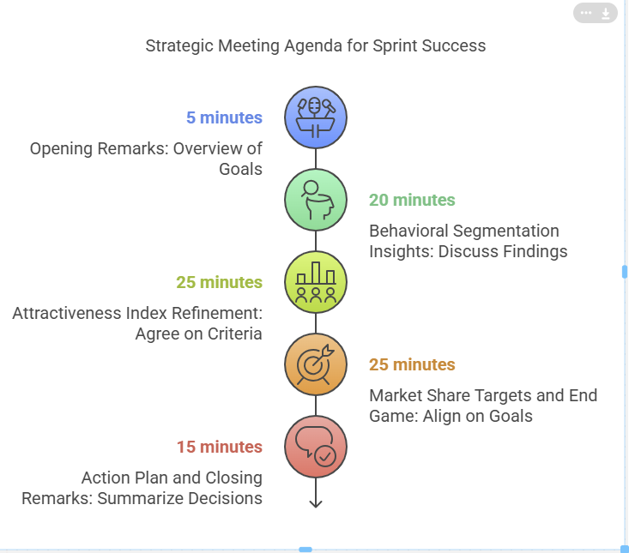

Final Reminders
Engagement Tips:
- Stay focused: Keep discussions tied to the sprint objectives.
- Be concise: Present points clearly and with supporting evidence.
Clarity and Precision:
- Ensure all tools and materials are complete before the meeting.
- Use data and examples to support your insights.
Icon: ⚡ An exclamation mark for readiness and urgency.

Final Instructions
Customized Review:
This sheet has been tailored to the sprint’s specific objectives. Please review it against your individual preparation to ensure alignment.
Feedback Mechanism:
After the meeting, share your feedback on this preparation process to help us refine and improve future materials.

